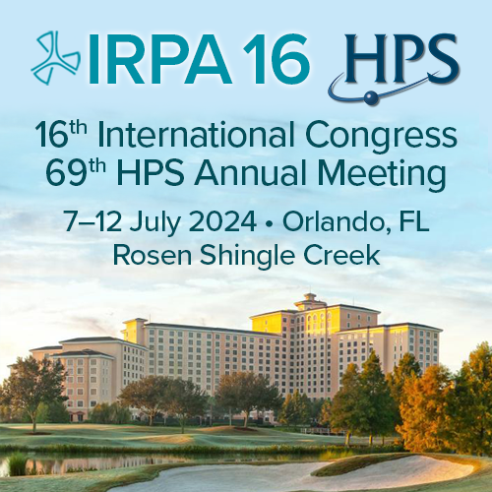
Charles Wilson, Continuing Education Programs Committee Chair

Calling all IRPA associate societies!

The Health Physics Society is preparing to help host you this coming July in sunny Orlando Florida and is currently soliciting Professional Enrichment Program Sessions (PEPs) as part of our pre-meeting enrichment program. These sessions usually last 90-180 minutes and try to cover a specific area of Health Physics well. Authors are renumerated at a set stipend.

Recent examples include:
- Radiation Safety Risk Mitigation in Y-90 Microsphere Administrations
- Alpha Spectroscopy for the Health Physicist
- and Critical Improvements for Health Physicists in Radiological and Nuclear Emergencies

Attendees pay extra for each PEP they wish to attend. If there are not enough registrations for a PEP it may be canceled, and the speaker not renumerated. These PEPs are currently planned to be held Sunday, July 7th, before the IRPA congress begins. The submission deadline for PEPs is 1 February 2024 and it will not be extended. Selected authors will be notified in March.

Authors can submit and provide more than one PEP course but will only be renumerated at the set (1 PEP) amount.

Please click here to submit your proposed course!

If you have any questions, don't hesitate to contact CEP Chair Charles Wilson.
Looking forward to seeing you in Orlando!

